SESSION 1 LAB EXPERIMENT
1. PALINDRONIC STRING:
#include <stdio.h>
#include <string.h>

int isPalindrome(char str[])
{
int i = 0;
int j = strlen(str) - 1;

while (i < j)
{
if (str[i] != str[j])
return 0;

i++;
j--;
}

return 1;
}

int main()
{
int n;
char words[100][100];

printf("Enter number of words: ");
scanf("%d", &n);

printf("Enter %d words:\n", n);

for (int i = 0; i < n; i++)
{
scanf("%s", words[i]);
}

for (int i = 0; i < n; i++)
{
if (isPalindrome(words[i]))
{
printf("First palindromic string: %s\n", words[i]);
return 0;
}
}

printf("No palindromic string found\n");

return 0;
}

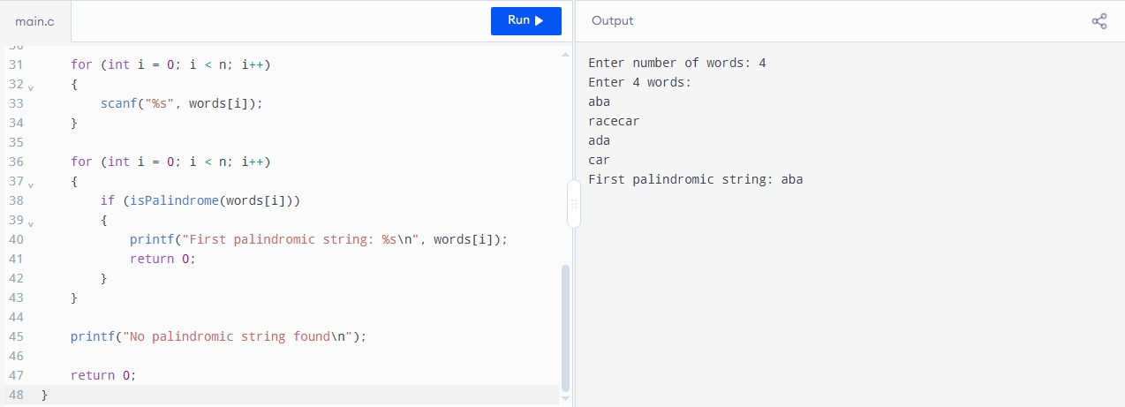

EXP 2. Common Elements in Two Arrays:
#include <stdio.h>

int exists(int arr[], int n, int key)
{
for (int i = 0; i < n; i++)
{
if (arr[i] == key)
return 1;
}
return 0;
}
int main()
{
int n, m;
int nums1[100], nums2[100];
int answer1 = 0, answer2 = 0;
printf("Enter size of first array: ");
scanf("%d", &n);
printf("Enter elements of first array:\n");
for (int i = 0; i < n; i++)
scanf("%d", &nums1[i]);
printf("Enter size of second array: ");
scanf("%d", &m);

printf("Enter elements of second array:\n");
for (int i = 0; i < m; i++)
scanf("%d", &nums2[i]);
for (int i = 0; i < n; i++)
{
if (exists(nums2, m, nums1[i]))
answer1++;
}
for (int i = 0; i < m; i++)
{
if (exists(nums1, n, nums2[i]))
answer2++;
}
printf("Answer = [%d, %d]\n", answer1, answer2);
return 0;
}
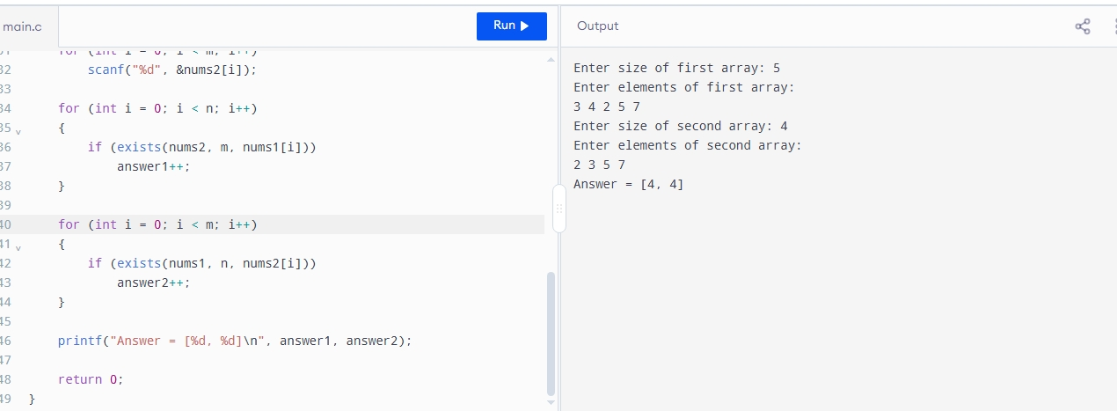

EXP 3. Sum of Squares of Distinct Counts:
#include <stdio.h>

int main()
{
int n;
int nums[100];
long long sum = 0;

printf("Enter size of array: ");
scanf("%d", &n);

printf("Enter array elements:\n");

for (int i = 0; i < n; i++)
{
scanf("%d", &nums[i]);
}

for (int i = 0; i < n; i++)
{
int distinct[100];
int count = 0;

for (int j = i; j < n; j++)
{
int found = 0;

for (int k = 0; k < count; k++)
{
if (distinct[k] == nums[j])
{
found = 1;
break;
}
}

if (!found)
{
distinct[count] = nums[j];
count++;
}

sum += count * count;
}
}
printf("Sum of squares = %lld\n", sum);
return 0;
}
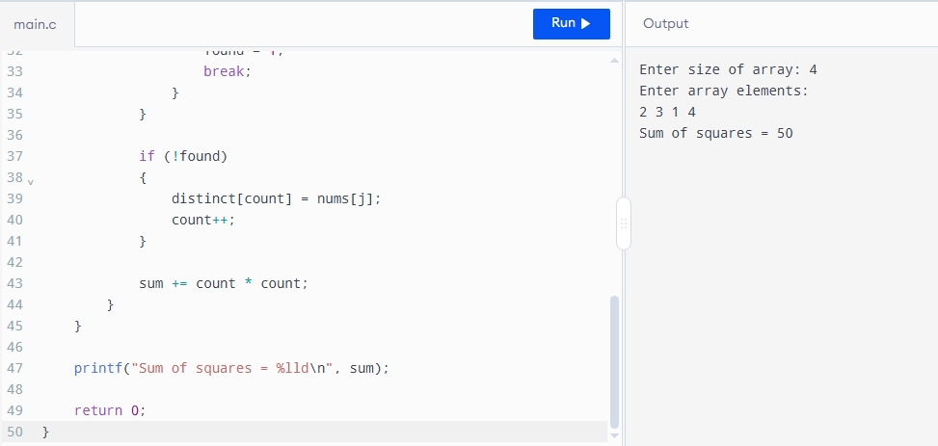

EXP 4: Equal Elements and Product Divisible by K
#include <stdio.h>

int main() {
int n, k;
int nums[100];
int count = 0;

printf("Enter size of array: ");
scanf("%d", &n);

printf("Enter array elements:\n");
for (int i = 0; i < n; i++) {
scanf("%d", &nums[i]);
}

printf("Enter k: ");
scanf("%d", &k);

for (int i = 0; i < n; i++) {
for (int j = i + 1; j < n; j++) {
// Check both conditions:
// 1. nums[i] == nums[j]
// 2. (i * j) is divisible by k
if (nums[i] == nums[j] && (i * j) % k == 0) {
count++;
}
}
}
printf("Number of valid pairs = %d\n", count);
return 0;
}
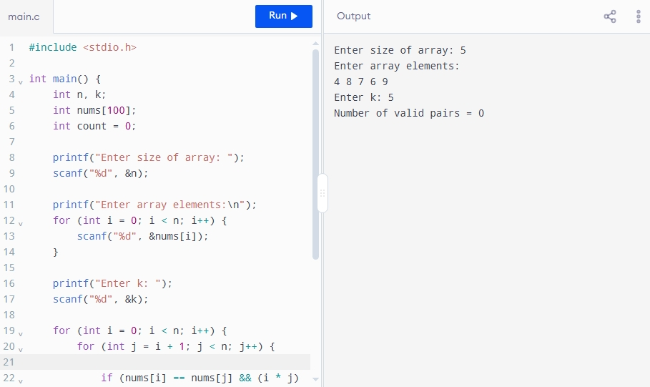

Time Complexity = O(n²)
Space Complexity = O(1)

EXP 5. Find Maximum Element — Least Time Complexity
#include <stdio.h>

int main()
{
int n;
int arr[100];

printf("Enter size of array: ");
scanf("%d", &n);

if (n <= 0)
{
printf("Array is empty\n");
return 0;
}

printf("Enter array elements:\n");

for (int i = 0; i < n; i++)
{
scanf("%d", &arr[i]);
}

int max = arr[0];

for (int i = 1; i < n; i++)
{
if (arr[i] > max)
{
max = arr[i];
}
}

printf("Maximum element = %d\n", max);

return 0;
}
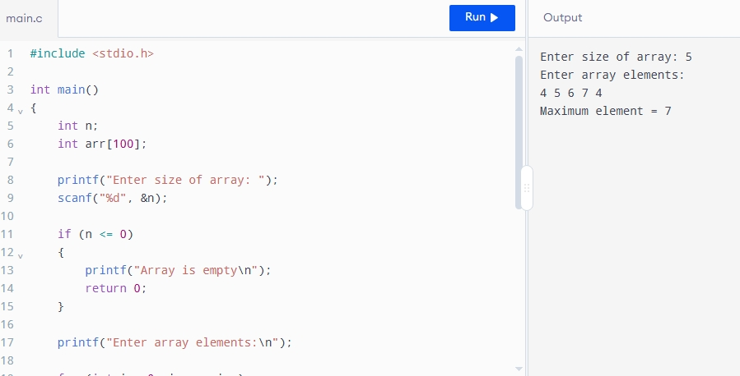

Time Complexity: O(n)
Space Complexity: O(1)

EXP 6 : Sort and Find Maximum
#include <stdio.h>

void swap(int *a, int *b)
{
int temp = *a;
*a = *b;
*b = temp;
}

int partition(int arr[], int low, int high)
{
int pivot = arr[high];
int i = low - 1;

for (int j = low; j < high; j++)
{
if (arr[j] < pivot)
{
i++;
swap(&arr[i], &arr[j]);
}
}

swap(&arr[i + 1], &arr[high]);

return i + 1;
}

void quickSort(int arr[], int low, int high)
{
if (low < high)
{
int p = partition(arr, low, high);

quickSort(arr, low, p - 1);
quickSort(arr, p + 1, high);
}
}

int main()
{
int n;
int arr[100];

printf("Enter size of array: ");
scanf("%d", &n);

if (n == 0)
{
printf("List is empty\n");
return 0;
}
printf("Enter array elements:\n");
for (int i = 0; i < n; i++)
{
scanf("%d", &arr[i]);
}
quickSort(arr, 0, n - 1);
printf("Sorted array: ");
for (int i = 0; i < n; i++)
{
printf("%d ", arr[i]);
}
printf("\nMaximum element = %d\n", arr[n - 1]);
return 0;
}
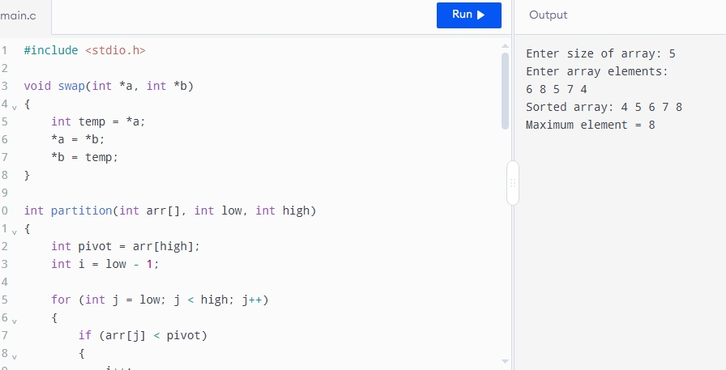
Average Time Complexity: O(n log n)

EXPERIMENT 7. Binary Search
#include <stdio.h>
int binarySearch(int arr[], int n, int key)
{
int low = 0;
int high = n - 1;
while (low <= high)
{
int mid = (low + high) / 2;
if (arr[mid] == key)
return mid;
else if (arr[mid] < key)
low = mid + 1;
else
high = mid - 1;
}
return -1;
}
int main()
{
int n, key;
int arr[100];
printf("Enter size of array: ");
scanf("%d", &n);
printf("Enter elements in sorted order:\n");
for (int i = 0; i < n; i++)
{
scanf("%d", &arr[i]);
}
printf("Enter key element: ");
scanf("%d", &key);
int result = binarySearch(arr, n, key);
if (result != -1)
{
printf("Element %d is found at position %d\n",
key, result + 1);
}
else
{
printf("Element %d is not found\n", key);
}
return 0;
}

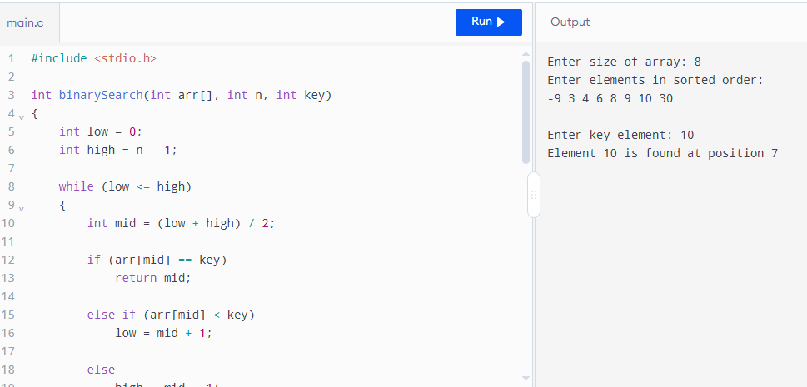

EXPERIMENT 8. Sort Array in O(n log n)
#include <stdio.h>

void swap(int *a, int *b)
{
int temp = *a;
*a = *b;
*b = temp;
}

void heapify(int arr[], int n, int i)
{
int largest = i;
int left = 2 * i + 1;
int right = 2 * i + 2;

if (left < n && arr[left] > arr[largest])
{
largest = left;
}

if (right < n && arr[right] > arr[largest])
{
largest = right;
}

if (largest != i)
{
swap(&arr[i], &arr[largest]);

heapify(arr, n, largest);
}
}

void heapSort(int arr[], int n)
{
// Build max heap
for (int i = n / 2 - 1; i >= 0; i--)
{
heapify(arr, n, i);
}

// Extract elements from heap
for (int i = n - 1; i > 0; i--)
{
swap(&arr[0], &arr[i]);

heapify(arr, i, 0);
}
}

int main()
{
int n;
int arr[100];

printf("Enter size of array: ");
scanf("%d", &n);

printf("Enter array elements:\n");

for (int i = 0; i < n; i++)
{
scanf("%d", &arr[i]);
}

heapSort(arr, n);

printf("Sorted array: ");

for (int i = 0; i < n; i++)
{
printf("%d ", arr[i]);
}

return 0;
}
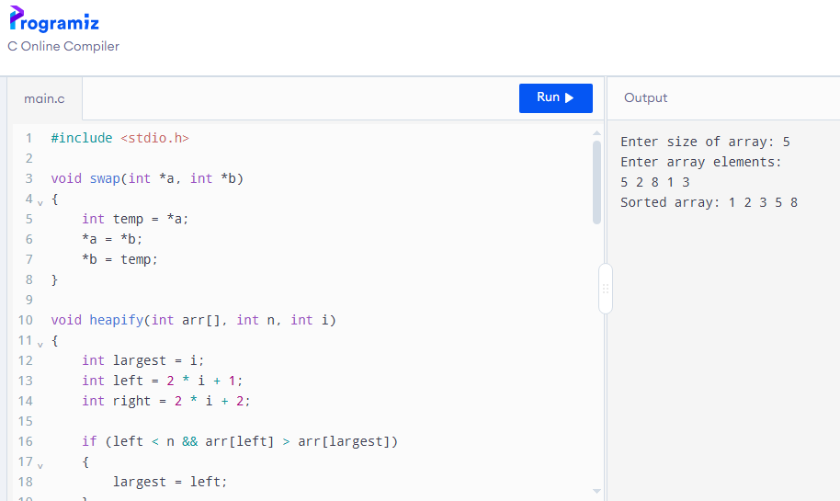
Time Complexity = O(n log n)
Space Complexity = O(1)

